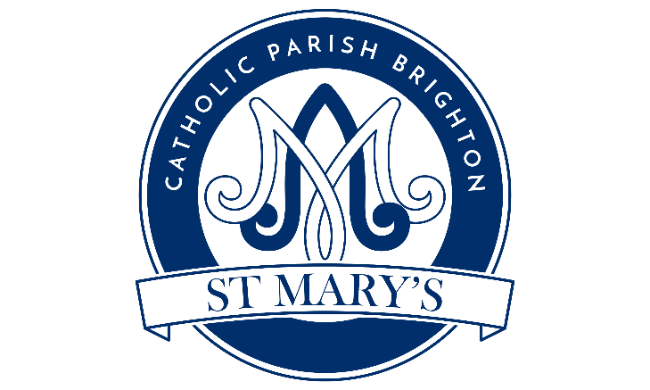

www.brightonstmary.com
5 SURRENDEN ROAD, BRIGHTON BN1 6PA
email: brightonstmary@abdiocese.org.uk, phone: 01273 554509
FIRST HOLY COMMUNION PROGRAMME
ENROLLMENT FORM
First Holy Communion is an important stage in your child’s spiritual development, and we want to help you in preparing your child for this most special Sacrament. When your child was baptised, he/she was welcomed into the family of the Church. Holy Communion is the Sacrament which binds us together as God’s family, providing strength and spiritual nourishment for our journey in faith together. During the preparation for this Sacrament, we will also be preparing for the Sacrament of Reconciliation (Confession).
In our Diocese, the usual age for receiving this Sacrament for the first time is 8 years of age (children in Year 3 or above).
CHILD’S FIRST NAME________________________________________________
SURNAME___________________________________________________________
DATE & PLACE OF BIRTH____________________________________________
DATE OF BAPTISM___________________________________________________
CHURCH OF BAPTISM_______________________________________________
Please note that if your child was not Baptised in St Mary’s, then we will need to see a copy of his / her Baptism Certificate. This MUST be done before your child can receive the sacraments of reconciliation or communion.
SCHOOL ATTENDED BY YOUR CHILD:

NAMES OF PARENTS/GUARDIANS OF THE CANDIDATE
Mother__________________________________Father__________________________________________
WHICH MASS DO YOU NORMALLY ATTEND
Church name and the time of the Mass you attend in person

YOUR HOME ADDRESS_________________________________________________________________
CONTACT PHONE NUMBER_____________________________________________________________
CONTACT EMAIL ADDRESS_____________________________________________________________
Email will be the main method of communication about the program, so please provide an email address which you check frequently.

PHOTOGRAPHY:
I give permission for my child to be photographed and for the photo to be displayed in Church, as part of the First Holy Communion celebration programme. Children’s names will not be identifiable with their photographs.
YES / NO

DISABILITY/ OTHER NEEDS THAT MIGHT NEED TO BE TAKEN INTO ACCOUNT:
If there are any known medical / learning issues which affect your child, and which should be known to the catechists, please let us know. These will be shared with the catechists, but not with others including not with other parents. Examples include Mobility difficulties, Asthma, Allergies, SEND etc..
__________________________________________________________________________
DECLARATION:
I would like my child to take part in the first holy communion program at St Mary’s Church. I undertake to co-operate in the preparation, especially by attending the children’s/parent meetings, as well as by my example of the practice of faith, through prayer and attending Mass on Sunday.
I understand that the leaders will take all reasonable care of the children.
SIGNATURE OF ONE OF THE PARENTS/GUARDIANS:

_________________________________________ DATE_______________________________________

Information provided on this form, together with all other personal data held about these individuals by the Parish and the Arundel & Brighton Diocese, is processed in accordance with the Diocese's Privacy Notice and GDPR.
In any event you will hear from us with further details in due course.

