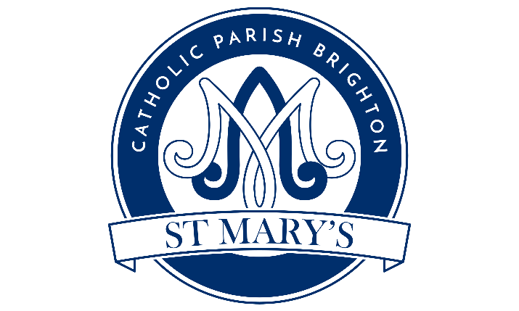
www.brightonstmary.com
5 SURRENDEN ROAD, BRIGHTON BN1 6PA
email: brightonstmary@abdiocese.org.uk, phone: 01273 554509
INFANT BAPTISM REQUEST FORM
Please print all information clearly.
Name of Child: First______________________Middle________________________Last________________________
Date of Birth ___________________________Place of Birth______________________________
Name of Mother: First____________________Middle_______________________Maiden________________________
Religion of Mother____________________________________________________________________
Name of Father: First_____________________Middle________________________Last__________________________
Religion of Father_____________________________________________________________________
Address: _____________________________________________________________________________
Mailing Address _________________________ Phone__________________________
How often do you attend Mass (weekly, monthly, never or other)?
Mother _____________________________Father________________________________
Church & Mass attended: _______________________________________________________________
How are you involved in parish life? Or would you like to get involved? ______________________________________________________________________________________
Requested Date of Baptism (choose two dates): ______________________________________________________________________________________
GODPARENTS:
- Name: __________________________________________________ Religion ________________
- Name: __________________________________________________ Religion ________________
We hereby request the Sacrament of Baptism for our child:
Father (signature) _________________________Mother (signature)____________________________

Can I have my child baptised?
For an infant to be baptised it is required that:
- the parents, or at least one of them, or the guardian, give their consent.
- there be well-founded hope that the child will be brought up in the Catholic faith.
Before a Baptism date can be booked, parents will meet with a priest to complete an application form and attend a Baptism preparation course, even if they have had another child baptised before.

​When and where does the course take place?
Baptism preparation for parents of infants takes place quarterly in our parish. Parents and catechists meet at St Mary's.

When does the ceremony take place?
Depending on circumstance and availability, Baptisms usually take place either at one of our Sunday Masses or outside of Mass (time and day arranged with the Parish Priest).
Who can be godparents?
Godparents must:
- Be over sixteen years of age
- Be a practising Catholic who has received the Sacrament of Confirmation and who lives a life of faith which befits the role to be undertaken.
- Non-Catholic Christians may act as Christian witnesses to the Baptism.
- Not be either the father or mother of the child to be baptised.
What does Baptism cost?
The church does not charge for administering the Sacraments but we ask for a donation of £50, to include the minister's time, the certificate and administration.

FOR OFFICE USE:
Received by Office: _________________________________________________________________
Course attended: ____________________________________________________________________
Date of Baptism: ____________________________________________________________________

Entered into the register: _____________________________________________________________
Certificate issued & sent: _____________________________________________________________

