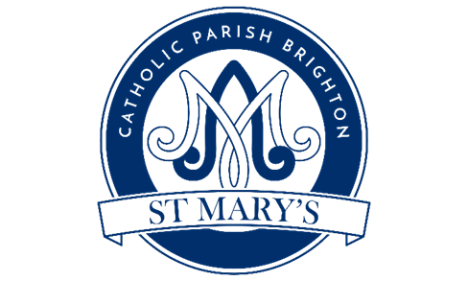
www.brightonstmary.com
5 SURRENDEN ROAD, BRIGHTON BN1 6PA
email: brightonstmary@abdiocese.org.uk, phone: 01273 554509

ENROLLMENT FORM FOR CONFIRMATION COURSE
Young adults are invited to become fully adult members of the Church by receiving the Holy Spirit and publicly confirming their commitment to be active followers of Jesus Christ. This is a serious commitment and involves a programme of preparation meetings and activities over months.
But like anything that brings great returns, it’s worth the effort!

CANDIDATE’S DETAILS

Full name: ________________________________________________________________________________
(as you would like it to appear on your Confirmation Certificate)

Name you would like to be known by during sessions: __________________________________________

Date of Birth: _________________________________ Place of Birth: ______________________________

School Name and Year Group as of September 2023:
___________________________________________________________________________________________

Which parish do you attend? _______________________________________________________________

Date of Baptism: _____________________________

Church of Baptism (full name & address): ______________________________________________________________________________________________________________________________________________________________________________

Church of First Holy Communion and Date:
___________________________________________________________________________________________
Please attach a photocopy of your Baptism Certificate, (which you can obtain from the Church of Baptism if necessary) and a photocopy of your First Holy Communion Certificate, if available

Address: __________________________________________________________ Postcode_______________

Home Phone no: ___________________________________________________________________________

Mother’s First Name: _______________________________ Surname: ______________________________

Religion: _____________________________________________

Father’s First Name: _______________________________ Surname: ______________________________

Religion: ______________________________________________

Mother and/or Father’s Email: ______________________________________________________________

Emergency Contact Number/s: ________________________________________________________________

Any medical condition, food allergies, or special dietary requirements you feel we should be aware of: _______________________________________________________________________________________
______________________________________________________________________________________________________________________________________________________________________________

Statement of Commitment:
I understand that there are certain requirements and I desire, of my own free will, to enter into preparation for the Sacrament of Confirmation. By signing this form, I commit to growing my relationship with Jesus Christ and my commitment to His Church in preparation for the Sacrament of Confirmation through:
• Attending Mass on Sundays and Holy Day of Obligation.
• Learning more about the Catholic Faith by attending religious education or school theology classes.
• Working to establish a practice of daily prayer.
• Engaging in works of charity and service.
• Attending designated retreats/events/meetings.
• Completing the preparatory requirements established by the diocese and parish either through Catholic School or the parish program. I also understand that not fulfilling these commitments may delay the date on which I am confirmed

Signed (Candidate): __________________________________________ Date: _________________________

As the candidate’s parent/guardian I understand that I am making a commitment to prepare my child for the Sacrament of Confirmation. I understand and agree with the preparatory requirements as set forth by the parish, and I will encourage my child through word and example, fostering their growth in the faith and their desire to be confirmed.

Signed (Parent): ______________________________________________ Date: ________________________

By completing this form, you give us permission to hold and process your personal information for particular purposes. For further information about how we process your data, see the privacy notice on our website.

